Experiment -7

Aim : To create scripts that interact with Selenium Server.

Example-1

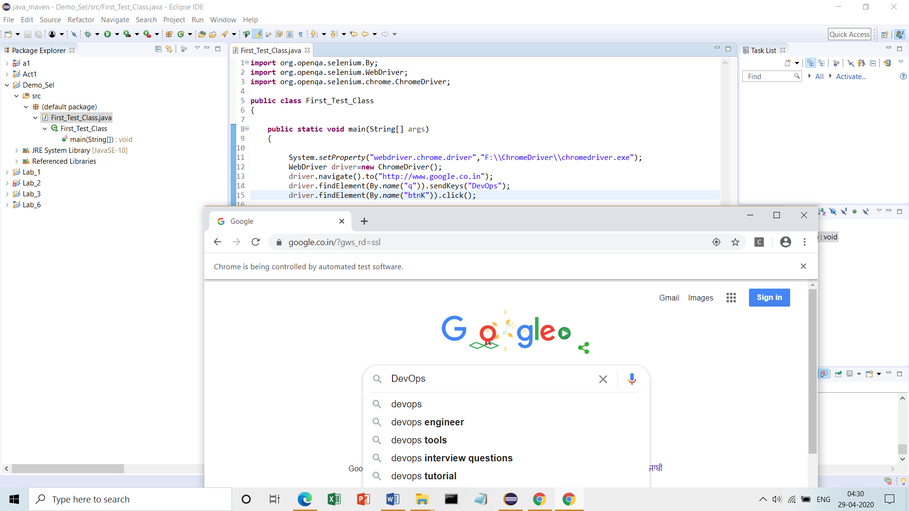

Example-2

